Meeting Agenda
date | 25/01/2024
time | 10:00 – 11:00
________________________________________________________________________________________________

discussion topics

* ethical approval
- no ethics → blanket ethics
- how to change ethical approval?
(personal information might be needed when I implement the application such as weight, height, and gender
I might need to put it in my essay as well to show the result)
- should I get an agreement from users when they sign in?

* testing device
with the newest version of android
(I can use the emulator, but as it is an app for tracking working out progress, I want to actually carry the device to the gym and try my app)

* project type
- Enterprise: Aims to develop and/or evaluate a product or service for a specific end user category.
- Development: Aims to test the student’s ability as a software developer and the project could be added to their portfolio afterwards.
(can it be an enterprise project? If not, what are requirements)

* dissertation
- what will the enterprise project dissertation be like? Should I include...
- how I developed the app (process )
- what tools and languages I used
- system architecture, scalability
- performance optimisation
- security concerns
- git usage and project management
- user friendly interface (why is it user friendly)
- testing process and user feedbacks

weekly updates

* plan and timeline
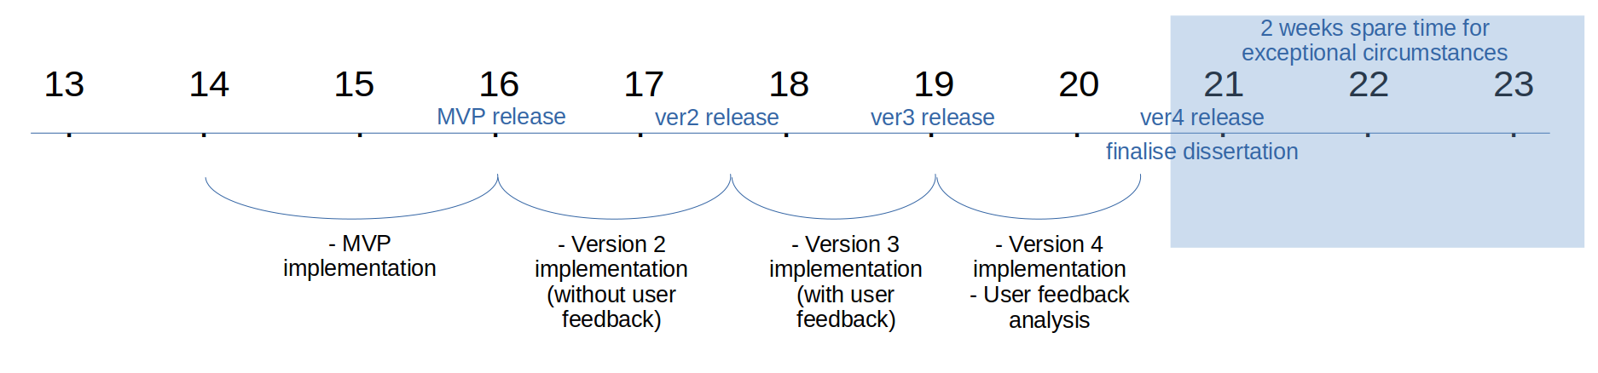
* check mark-scheme
* get LaTeX
* dissertation template
* language and environment setting (Kotlin – android studio)

priority tasks

* git repository
* develop the minimal viable product and release
* what will MVP be like? - what to implement for the MVP in detail
(should involve basic security features, visualisation of muscles based on user records)
* read study about muscle growth optimisation
Note
________________________________________________________________________________________________

Important dates
poster day week 22
submission week 24
9/5/2024 13:00 dissertation deadline

Type of project
Enterprise: Aims to develop and/or evaluate a product or service for a specific end user category.
- For people want to track on their working out process
- Universal design (help ADHD people), focus on usability
Development: Aims to test the student’s ability as a software developer and the project could be added to their portfolio afterwards.

Minimum Viable Product → will focus on ‘development’ part of project mostly,
When planning your project you should define a minimum viable product(MVP). This should be enough to pass the unit that you will be able to complete on time after around half of your alotted time and should be discussed with your supervisor when confirming your project.
If your project is harder than expected, then you have the MVP to fall back on, otherwise you can add extra features to the MVP to increase the challenge of your project.
You should be constantly reviewing your progress during TB2, for yourself and for your supervisor. If you think you cannot finish the MVP you should let your supervisor know immediately.
* gym post - after I finish to make my minimal viable product

You will be working on an in-depth, challenging project. Your supervisor will ensure that the project is appropriate and relevant.
You will need to demonstrate the ILOs which have been designed to match graduate Computer Science Jobs:
Demonstrate understanding of research-level material
Identify a well-motivated, scientifically interesting challenge.
Engage in a suitable approach to solving said challenge.
Critically evaluate your solution in a suitable manner.
Present your results in written and verbal form.
Manage your own time, and decide your own objectives

Ethics
All projects will need an ethics statement at the beginning of the dissertation, and all projects will fall into one of three categories
first assumption : Projects that do not require ethical approval because they do not collect or process any relevant data.
But will be… : Projects that can be reviewed by your supervisor under “Ethics Appliction 0026”, because they are judged to be low ethical risk.

Viva
They will do so from reading the thesis and watching/conducting your viva.
- To showcase parts of the project which cannot (easily) be incoporated into the dissertation.
- To get assurance that you have done the work yourself.
- To discuss any mistakes or omissions within the dissertation.
- To correct any misunderstandings the second marker may have had about the work.
- To explore your understanding of the project area.

Marking
How your project is assessed will depend on many specific factors, including the type of degree it is for (BSc, MEng), the type of project (enterprise, research, theory, development etc.), and what achievements you claim in your thesis. For example if you tell us in your thesis that the usability of the software you developed is your most important achievement, your markers will most likely weight usability higher than other criteria.

Challenge and Achievement
- Technical Approach
- Critical Interpretation
- Report Presentation

